**Replacing Parts on A Swivel Glider**

Table of Contents

Parts of the Chair 2

Changing the Swivel Sleeve 3

Tools 3

Changing the Swivel 4

Tools 4

Removing a Broken Post 7

Tools 7

# Parts of the Chair

Although they may look different, every glider chair is made the same.

**Bucket**

* 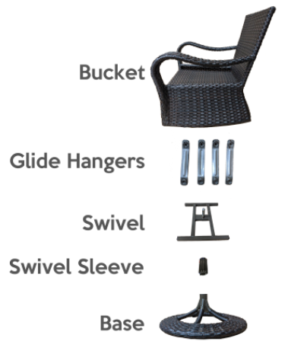Part of the chair you sit-in

**Glider hangers**

* Four flat pieces of metal that have bearings in each end that connect the bucket to the swivel. This is what allows the chair to glide back and forth

**Swivel**

* A sturdy heavy construction that the glider hangers attach to. The swivel has a post that inserts into the swivel sleeve

**Swivel sleeve**

* A nylon insert that goes into the chair base that allows the swivel to operate freely

**Base**

* The part of the chair that is in contact with the ground

**Hardware**

* Eight bolts and eight nylon nuts that bolt the glider hangers to the swivel and the bucket

# Changing the Swivel Sleeve

Time: 10 minutes

## Tools

* Soft surface to work on
* Hammer
* Wood dowel or small block of wood
* Partner
  + Makes it easier but is not necessary

The swivel sleeve is a wear item. From time to time over the life of the chair, it may be necessary to replace it.

1. Pad the surface you will be working on so you do not scrape or mar the finish
2. Flip the chair over on the padded surface

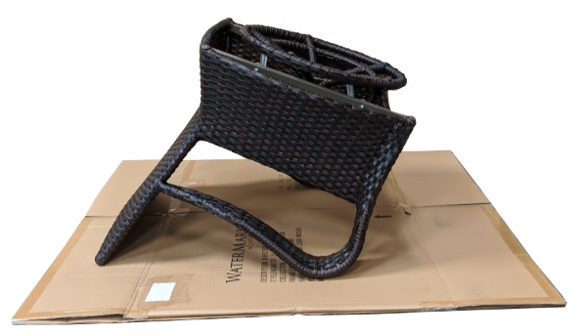

1. Remove the base from the chair
   1. Have a friend hold down the bucket
   2. Grab the base like a steering wheel
   3. Consistently lift with as much force as you can safely accomplish while turning the base back and forth like a steering wheel
      1. If you cannot muster enough force, you can use two small screwdrivers to pull back the clips on the swivel sleeve that are locked in the groove. This is not necessary if you can lift hard enough.

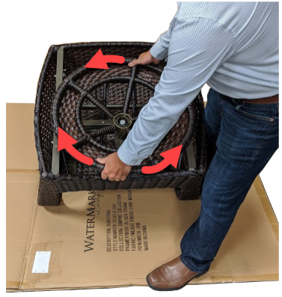

1. Once the base is off the chair, palce a piece of wood, the base of a hammer, or a large socket against the bottom of the swivel sleeve. Hit it with firmly with a hammer to move swivel sleeve out of the base. It could require forceful blows with the hammer to get it to move. It is compressed in the tube.

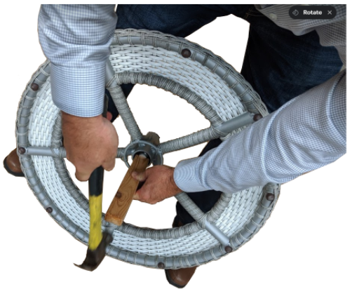

1. Take the new swivel sleeve and place it firmly in the swivel sleeve hole in the base
2. Tap with a hammer until it is fully seated

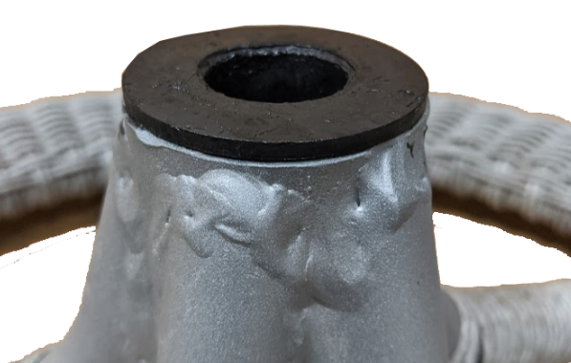

1. Apply a light amount of synthetic grease if available to the post on the swivel.
2. Holding the base like a steering wheel, align the swivel post with the hole in the swivel sleeve. Turn back and forth like a steering wheel till the base is fully seated

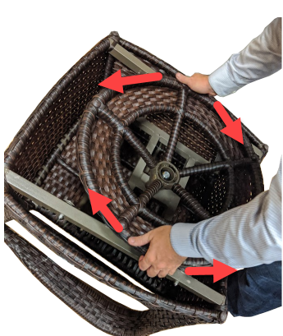

1. Flip the chair over and enjoy!

# Changing the Swivel

Time: 15 Minutes

## Tools

* Soft surface to work on
* Tray for nuts, bolts, and washers
* Wrench
  + Two size nuts can be found on the chairs
    - 11mm or 7/16”
    - 13mm or 1/2"
* Allen wrench
  + 4mm
* Hammer
* Partner
  + Makes it easier but is not necessary

Changing the swivel is easiest if you remove the base first. Please follow the Removing the Base instruction steps 1, 2 & 3 to remove the base.

If the swivel post is broken off in the swivel sleeve, you will need a large metal punch and strength to get it out. If you are not comfortable changing the oil on a car, you may not want to remove a broken swivel post. Please let us know, and we will be happy to help make arrangements to assist.

1. Remove the four nuts and bolts that hold the glider hangers to the swivel. Place them in a parts tray as you remove them for later use.



1. Once all four bolts are removed, you can easily remove the swivel
2. The new swivel is directional.
   1. The post faces away from the chair and towards you
   2. The post is not in the center of the swivel. The post should be towards the back of the chair.

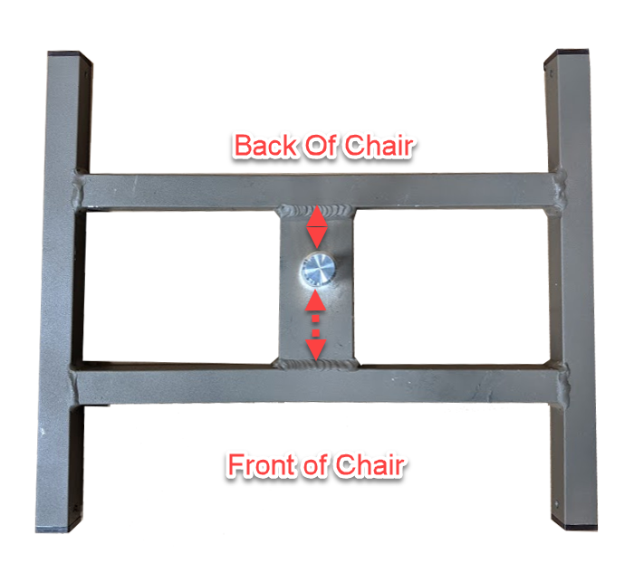

1. With a new swivel in place, in the correct orientation, insert the bolts first through the glider hanger and then through the holes in the swivel.
2. Tighten the nylon nuts on the bolts
3. Move the swivel back and forth to make sure it moves freely on the glider hangers. If you over tighten the nuts, the chair will be stiff. Loosen each nut a turn till the swivel moves freely on the glider hangers
4. Replace the base on the swivel post.
   1. Follow steps 7 and 8 of Removing the Base

# Removing a Broken Post

Removing a broken post from a swivel sleeve can be difficult. It should only be attempted by someone comfortable swinging a hammer with force.

## Tools

* Soft surface to work on
* Hammer
* Large metal punch
* Wood dowel or small block of wood

1. Secure the base with the bottom facing up. Take care to make sure there is room for the broken post to be driven out of the sleeve.

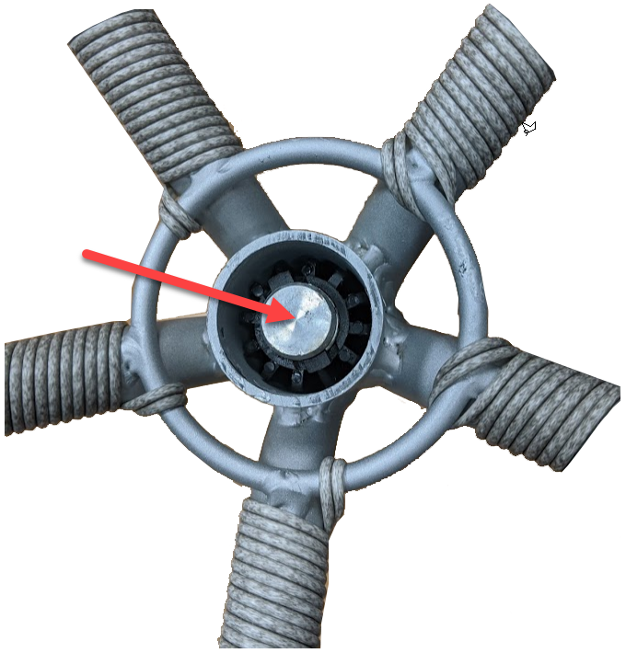

1. Once the broken post is driven out, follow the instructions for replacing the swivel.